1. **The focus is not displayed on the “Войти» button after using tab order**

Steps to reproduce

1. Open the “VK Messenger” app
2. Write correct email to email field
3. Press TAB
4. Write correct password to password field
5. Press TAB
6. Pay attention to focus position

Actual result

The focus is not displayed on the “Войти» button after using tab order

Expected result

The focus is displayed on the “Войти» button after using tab order

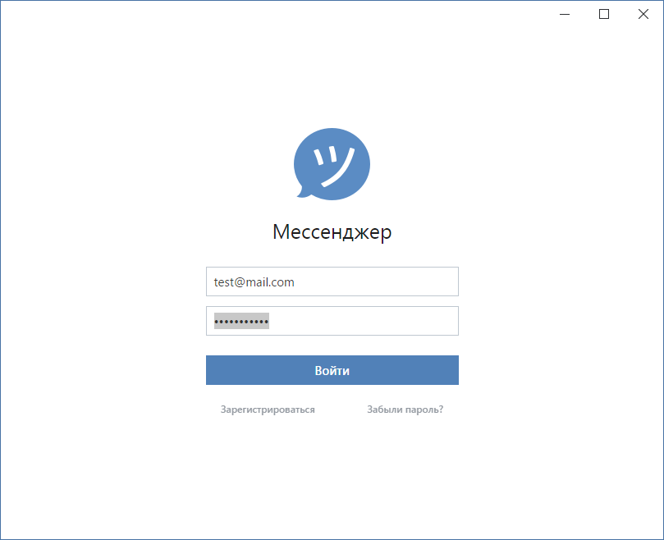

1. **Context menu (Copy, past, cut) is not shown on the dialog page after using right click**

Steps to reproduce

1. Choose text field
2. Press right mouse button
3. Pay attention to the lack of menu

Actual result

Context menu is not shown on the dialog page after using right click

Expected result

Context menu (Copy, past, cut)is shown on the dialog page after using right click

**3. The application is not updated after clicking the "Oбновить" button on the “Обновление” tab**

Steps to reproduce

1. Start application
2. Go to the settings
3. Go to the “Обновление” tab
4. Click the “Обновить” button
5. Pay attention to the version application

Actual result

The application is not updated after clicking the "Oбновить" button

Expected result

The application is updated after clicking the "Oбновить" button

